David Gelagay & Caitlin Neppl

Group 3 Assignment: Design Research

**Part 1: Design Research Summary**

Data Collection Method 1: Survey

For the survey data collection method, we created a Qualtrics survey using the questions we had created with the project plan and distributed it in the form of a post on the subreddit r/houseplants (deleted when we got enough responses). We all worked together to create the questions and so were all responsible for this method. Overall, we got 12 responses. The demographics of the respondent group were largely female, making up ⅔ of the results. The age of the respondents ranged from 19 to 43, with the majority of the participants being between the ages of 18-25, most likely because of where we chose to post the survey.

Selected results from this data collection method are shown in the table below:

|  |  |  |  |
| --- | --- | --- | --- |
|  | | Number of Respondents | Percent of Respondents (%) |
| Tech Literate | | 12 | 100 |
| History of Plant Death | | 12 | 100 |
| Current Tracking Method | | -- | -- |
|  | None | 9 | 75 |
|  | App | 2 | 16.67 |
|  | Paper record | 1 | 8.34 |

From the responses, we learned that all of those who responded were tech literate. This was not surprising, as we got the results from an online source, but it does show that the subsequent responses were characteristic of a group who was familiar with using technology. This makes it clear that if an app were to exist, this group would be able to use it, and puts their responses in that context. However, only 9 of the 12 respondents have methods of explicitly caring for their plants, with only one using a smartphone app. All 12 of the respondents have had a history of plant death; the reasons behind these deaths are expanded on in the below graph: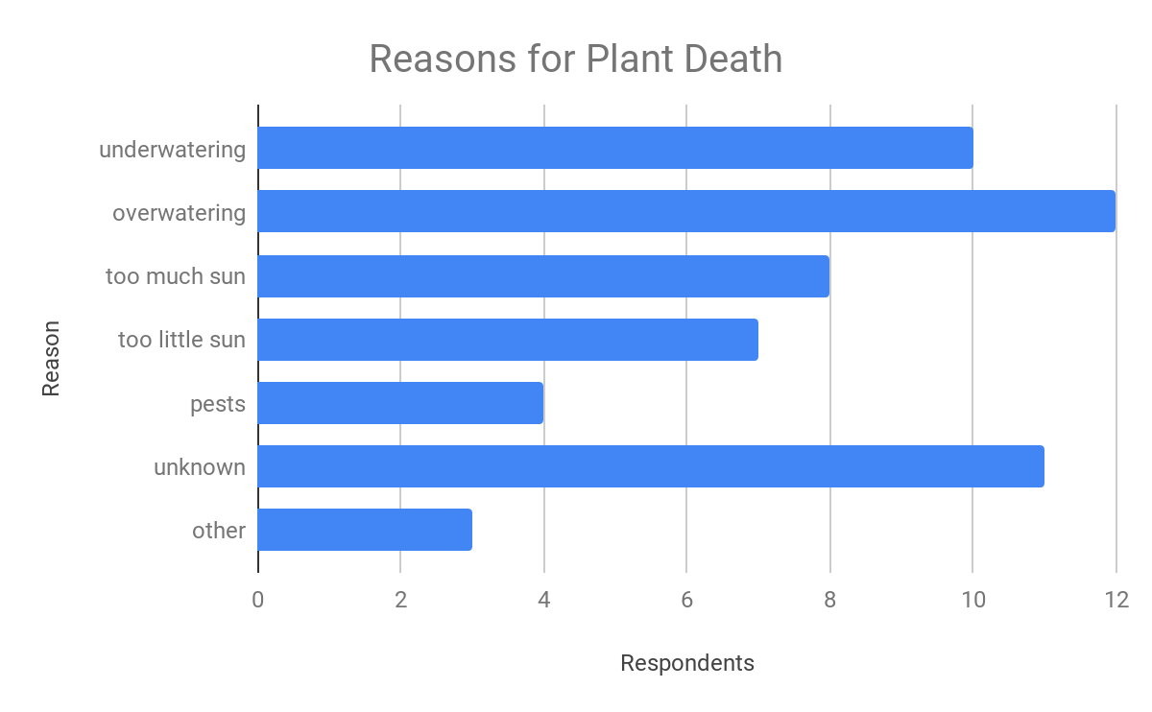

The reasons behind the plants’ deaths spanned several factors, with many respondents seemingly hazarding guesses as to what killed the plants. Over 91% of respondents indicated that when plants died, they usually didn’t know the reason for their deaths. We interpreted this to mean that many of the participants could benefit from some way of organizing their care to prevent deaths, or at least provide a learning experience from when plants die so they can cross-reference their actions with the results.

Data Collection Method 2: Diary

With the diary data collection method, we created a template diary page for the participant to fill out based on when they attended to the plant. This template asked them to record: time of care, type of care (watering, fertilizing, repositioning, just looking at, etc), and any specific thoughts while at the plant. Each of us were responsible for finding at least one participant and tracking their plant activity over a five-day period. In total, we got four respondents from our acquaintances and friends. Of our participants, one had one plant, and three had five or more. Three of the participants were in the age range of 18-25, and one was 60 years old. Two of the participants kept very low maintenance plants (succulents), which affected the data.

The results of the diary are depicted in the table below:

|  |  |  |  |  |
| --- | --- | --- | --- | --- |
|  | Participant 1 | Participant 2 | Participant 3 | Participant 4 |
| # of times Watered | 0 | 3 | 1 | 2 |
| # of times Visited | 3 | 4 | 4 | 3 |

Based on the results from the diaries, we learned that plant owners visit their plants at the same rates regardless of whether or not they are watering them. This indicates that people are often looking at their plants even if they’re not maintaining them so documenting the progress probably wouldn’t be an inconvenient additional step. One of the respondents noted that they felt compelled to check on their plants more often due to their participation in the study. This may have skewed the results a little.

**Part 2: Group Reflection**

All group members met at 2 PM October 27th to discuss the results of our research in our lovely home.

We found the survey to be the most useful data collection method due to the larger sample size compared to the diary. Twelve people answered the survey so we were able to reasonably find patterns in their answers. The diary could have provided more opportunity for tracking patterns but were not able to fully utilize it because only four people kept the diary over a five-day period of time. This short period of time along with the small sample size made it difficult to analyze the data. Another factor that made analyzing the diaries difficult was the fact that two of the respondents had succulents. Since these plants require very little watering, those two participants had minimal data in their diaries. If we were to do additional research, we would increase our data collection time period to 2 or more weeks in order to accommodate the less frequent succulent watering schedule. We would also involve more participants to get a better spread of data.

For the most part, aside from those outliers, our results were in line with each other. Based on our findings we came to the conclusion that a calendar feature would indeed be helpful when tracking plant progress, since a majority of the plant deaths are related to forgetting about some aspect of the plant’s care, with many being related to the watering schedule. Additionally, a gallery feature that allows you to take a picture on a calendar date and add notes would be helpful as well because most of the participants had a hard time noticing changes of their plants.

**Part 3: Appendices**

Survey Questions:

Demographics:

-age

-gender

-tech literacy

Survey Questions

1. Do you currently use any tools to keep track of everyday (non-plant related) tasks and

progress? If so, what?

2. How do you currently keep track of your plant progress?

3. How much time per week do you spend taking care of your plants?

4. How many plants do you own?

6. Which plants require most attention?

7. Have you had plants die before? If so, for what reason?

8. How often do you water your plants?

9. Do you do them individually or all at once?

10. Do you ever forget to water them?

11. Do you fertilize? How often

12. How did they know what to do for plant care? - followed instructions when purchased,

googled it, asked someone, have had one like it before, winging it?

13. How do you start your plants (i.e. Seeds, propagation, toddler plant)

14. Do you ever take pictures of your plants? If so, how often?

15. Why do you keep plants?

16. Do you name your plants?

17. Are you the only one responsible for your plants? If not, who else is?

Diary Outline:

|  |  |  |  |
| --- | --- | --- | --- |
| Time | Plant (if several, list them) | Action (water, fed, appreciated) | Additional Notes |
|  |  |  |  |
|  |  |  |  |
|  |  |  |  |